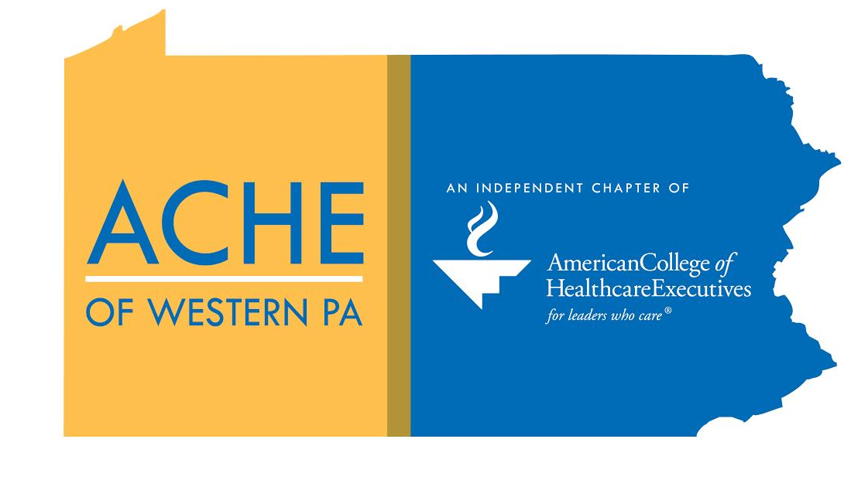
Sdfadgfafdgasfdsafdfdsafdsaasfdsadf
ACHE OF WESTERN PA

2019 sponsorship Program
Client

TABLE OF CONTENTS

Contents
TABLE OF CONTENTS 2
ABOUT ACHE of WESTERN PA 3
2019 SPONSORSHIP PACKAGES – ANNUAL 4
2019 SPONSORSHIP PACKAGES – EVENT & HOST 5
2018 EVENTS 6
Anticipated 2019 EVENTS 7
MEMBER ORGANIZATIONS 8
SPONSORSHIP COMMITTEE 11

ABOUT ACHE of WESTERN PA

VISION STATEMENT
QUICK FACTS
To encourage healthcare professionals in the region through opportunities for collaboration, learning and innovation
- Serves 26 counties of Pennsylvania, from Lake Erie to West Virginia
- Nearly 100 tertiary and community hospitals in the Western PA region
- Provides partnerships with accredited colleges that provide innovative education and research in information technology and life sciences
- Offers continuing education credits for ongoing learning and maintaining access to cutting-edge industry knowledge
- Enables members the opportunity to maximize professional potential by earning the premier credential in healthcare management, an ACHE Fellow (FACHE) board certified in healthcare management
- Offers access to one of the largest professional affiliated healthcare organizations in the American College of Healthcare Executives (ACHE)
- Members receive reduced fees for educational programs and networking receptions
- Excellent opportunities to develop professional relationships and gain mentors/mentees
- Provides the best way for healthcare leaders to connect, succeed, learn, advance and lead.

MISSION STATEMENT
To create an environment where healthcare leaders can access industry-leading education, network with colleagues from a diverse base of healthcare leaders, and support each other in advancement to Fellow status and achievement of career goals
2019 EXECUTIVE BOARD
Committee Chairpersons
Advancement
Natalie Bulger, FACHE, CHC

Early Careerist Network
Evan Finkelstein, MHA

Programming
Kim Fierst, MHA

Marketing & Membership
Samantha Yeung, PAHM

Sponsorship
Carrie Ennis, FACHE

Diversity Advisory Board Representative
Denise Johnson, MD, FACHE

Directors-at-Large
Michael Busch, MPM
AJ Harper, MBA
Kevin Broom, PhD
Dorene Sommers, RN, MBA
Mike Post, FACHE
Stephanie Dorwart, MHA

President
Caitlin Guadi, MHA

Vice President
Alex Lackos, MHA

Treasurer
Kelly Blake, DNP, MBA

Secretary
Samantha Yeung, PAHM

Immediate Past President
Natalie Bulger, FACHE, CHC

ACHE Regent
Jean Tauber, FACHE

Student Chapter
Representative
Kelsey Hooker

Total Affiliates ~430
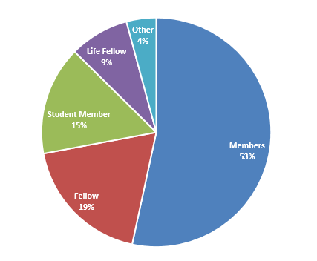
Membership represents over 180 healthcare organizations
2018 MEMBER DEMOGRAPHICS

2019 SPONSORSHIP PACKAGES – ANNUAL
Annual Sponsorships
 | Diamond | Platinum | Gold
 | $2,500 | $1,500 | $750
RECOGNITION and HOSPITALITY OPPORTUNITIES
Exposure to nearly 400 ACHE of Western PA Chapter Members | ✓ | ✓ | ✓
Welcome email with company information sent to distribution list | ✓ | ✓ | ✓
Opportunity to interact with Chapter Board Members | ✓ | ✓ | ✓
One yearly subscription to all chapter publications | ✓ | ✓
Exclusivity to Diamond Sponsorship (1 Diamond Sponsor per year) | ✓
Sponsor escort at Chapter events for key introductions | ✓
MARKETING OPPORTUNITIES: NEWSLETTER / EMAILINGS
Company advertisement space in quarterly newsletter in the sponsor year | ✓ | ✓ | ✓
Company logo on quarterly newsletter with quick hyperlink to company  website | ✓ | ✓ | ✓
Company logo on all Chapter email communications to Chapter distribution list (approximately 700 recipients)  - Registration Announcements  - Member Spotlights  - Messages from the President | ✓ | ✓ | ✓
Brief description of company & its offerings in the quarterly newsletter | ✓ | ✓
One use of chapter mailing list* | ✓ | ✓
Submission of a thought leadership piece to the Chapter Newsletter | ✓
MARKETING OPPORTUNITIES: WEBSITE
Corporate logo with hyperlink on the ACHE of Western PA Chapter Sponsor web page | ✓ | ✓ | ✓
Company logo on event fliers and registration pages | ✓ | ✓ | ✓
Corporate logo with hyperlink on the ACHE of Western PA Chapter home  page | ✓ | ✓
Exposure on ACHE of Western PA social media sites – sponsored post quarterly | ✓
MEETINGS and EVENTS
Invitation/admission to all events (Diamond: 3 tickets, Platinum: 2 tickets, Gold: 1 ticket) *Does not apply to co-hosted events such as the PAHS | ✓ | ✓ | ✓
Verbal acknowledgement at all ACHE events and educational programs | ✓ | ✓ | ✓
Presentation opportunity during allotted event time (Diamond: 5 minutes, Platinum: 2 minutes) | ✓ | ✓
Recognition on registration brochure and other collateral materials at events | ✓
Space for poster/displays/other recognitions at meetings and social events | ✓
*Emailing will be facilitated by ACHE of Western PA

2019 SPONSORSHIP PACKAGES – EVENT & HOST

Event Sponsorships
8 Event Opportunities per Year | Platinum | Gold | Silver
 | $1,000 | $500 | $250
OPPORTUNITIES and BENEFITS
Company logo on event fliers and registration pages | ✓ | ✓ | ✓
Verbal mention at event | ✓ | ✓ | ✓
Invitation/admission to all events (Platinum: 2 tickets, Gold: 1 ticket) | ✓ | ✓
Networking opportunities | ✓ | ✓
Presentation opportunity during allotted event time (Platinum: 5 minutes, Gold: 2 minutes) | ✓ | ✓
Space for set up and poster/flyer display | ✓ | ✓
Exclusive event sponsorship of selected event | ✓
One use of chapter mailing list* | ✓
Sponsor escort at event for key introductions | ✓
*Emailing will be facilitated by ACHE of Western PA

Event Hosting Facilities
 | Host Facility* | Host Facility w/ Complimentary Catering**
BENEFITS
Given mention/recognition in both the program material and ACHE of Western PA website for the registration period and one month following the program | ✓ | ✓
Given mention/recognition on program material and ACHE of Western PA website for registration period and extended to six months following the program |  | ✓
Organization logo with hyperlink on the ACHE of Western PA website for registration period and six months following the program |  | ✓
*Facilities that host an educational program on their premises free of charge
**Facilities that host an education program on their premises free of charge and contribute food/refreshments free of charge during the education program

2018 EVENTS
Event | Date | Description/Details
2018 Volunteer Networking  – Bar Louie, Pittsburgh | January 17, 2018  5:00pm | Members interested in volunteering with the chapter were invited to network with current volunteers– drink tickets and appetizers were provided. (FREE Event)
Breakfast with the CEO  –Erie, PA | March 22, 2018  7:30am | ACHE welcomed Chuck Walczak, FACHE as the featured guest for the kick off to the Northern Region Events (FREE Event)
Pennsylvania and NJ Chapter Reception  –Chicago, IL | March 27, 2018  6:00pm | Joined all PA and NJ ACHE Chapters for reception at Congress – Registration is FREE for the event and includes complimentary food and refreshments
Robert Morris Spring Lecture  – Moon, PA | April 12, 2018  5:00pm | Offered qualified education credits for the cohosted panel event - Health Equity: A Health Department and Community Challenge
Erie Education Event  – Erie, PA | April 25, 2018  5:00pm | Career Positioning: Strategically Mapping Your Early Career Development
Women’s Leadership Conference with HFMA  – Pittsburgh, PA | April 26, 2018  All Day Conference | Joint event with HFMA Western PA Chapter – Full day education including Developing an Environment of Civility and Respect in Healthcare Organizations
Pittsburgh Education Event with HIMSS  – Pittsburgh, PA | May 8, 2018  5:00pm | Joint event with Western PA HIMSS - The Endgame for Gamification in Healthcare *Hosted Event
Erie Education Event  – Erie, PA | May 8, 2018  7:30am | Building the Hospital of Tomorrow
Next Generation in Leadership Seminar  – Pittsburgh, PA | May 16, 2018  5:00pm | How to Develop Your Unique Leadership Style (FREE to members)
Pittsburgh Education Event  – Pittsburgh, PA | June 14, 2018  5:00pm | Building the Hospital of Tomorrow *Sponsored Event
ACHE Western PA Summer Networking Event  – Pittsburgh, PA | July 24, 2018  5:30pm | Annual summer networking event open to all members and potential members (FREE Event)
Dinner with the CEO  – Pittsburgh, PA | August 20, 2018  5:30pm | Hosted Chad Townsend, CEO of Millie’s Homemade Ice Cream for an intimate dinner with ACHE members
Pittsburgh Education Event  – Pittsburgh, PA | September 10, 2018  5:00pm | Developing Mentoring and Coaching Skills
Next Generation in Leadership Seminar  – Pittsburgh, PA | September 19, 2018  5:00pm | Tackling Interviewing Anxiety (FREE to members)
Erie Education Event  – Slippery Rock, PA | September 20, 2018  5:00pm | Developing Mentoring and Coaching Skills
Pittsburgh Education Event  – Cranberry, PA | September 28, 2018  1:00pm | Integrating Acute to Post Acute Care Settings

5th Annual Western PA Healthcare Summit  – Cranberry Township, PA | October 19, 2018  All Day Conference | Co-host of annual healthcare summit including panel session Bending the Execution Curve *Sponsorship for this event is separate
Dawn Gideon Lecture (Hosted by University of Pittsburgh)  – Pittsburgh, PA | November 12, 2018  1:00pm | Offered qualified education credits for the Annual Dawn Gideon Lecture – Innovation Impact
Erie Education Event  – Erie, PA | November 15, 2018  7:30am | Healthcare Executive role with the Opioid Crisis (FREE for students)
Annual Event  - Pittsburgh, PA | December 6, 2018  5:30pm | Annual member meeting – keynote speaker Karen Feinstein, PhD. Hosted clothing drive to benefit local charities (FREE to members) *Sponsored Event
Erie Education Event  - Erie PA | December 14, 2018 | Developing an Environment of Civility and Respect In Healthcare Organizations

Anticipated 2019 EVENTS
In addition to the events listed below we anticipate two early careerist events, a summer networking event, and at least four additional education sessions in Pittsburgh with approximately five additional events in the Erie area.
Annual Volunteer Networking Event  – Pittsburgh, PA | January, 2019 | Members interested in volunteering with the chapter were invited to network with current volunteers– drink tickets and appetizers were provided. (FREE Event)
Education Event  – Pittsburgh, PA | February 25, 2019 | Simulations in Healthcare – Education and Engagement Event
Pennsylvania and NJ Chapter Reception  –Chicago, IL | March 5, 2019 | PA and NJ ACHE Chapters host reception at Congress – Registration is FREE for the event and includes complimentary food and refreshments
Dinner with the CEO  - Pittsburgh, PA | August 14, 2019 | Featured CEO will be Emmai Alaquiva, Emmy Award Winner and CEO of Ya Momz House, Inc
Education Event  – Cranberry, PA | September 27, 2019 | Education event that follows the Healthcare Council of Western PA Fall Conference
Annual Event and Celebration  - Pittsburgh, PA | December 5, 2019 | Annual member meeting – includes a keynote address from ACHE national leadership (FREE to members)

MEMBER ORGANIZATIONS

ACMH Hospital | DNA Advanced Pain Treatment Centers
Aedos Health Services | Duquesne University
Aetna Corporation | Edgewood Surgical Hospital
AHN Allegheny General Hospital | Erie County Department of Health
AHN Jefferson Hospital | Erie Homes for Children & Adults
AHN Saint Vincent Hospital | Ernst & Young LLP
AHN Saint Vincent Medical Group of Corry | Excela Health
AHN West Penn Hospital | Excela Medical Group
Air Methods Corporation | Fayette Regional Health System / Uniontown Hospital
Allegheny Health Network | Foundation Radiology Group
Alle-Kiski Medical Center | Gannon University
Altius Healthcare Consulting Group | Gateway Health Plan
American Intercontinental Healthcare Group | Gateway Rehabilitation Center
Aramark | GE Healthcare
Astellas | GE Transportation
AstraZeneca | Grant Foundation
Baptist Homes Society Providence Point | Grove City Medical Center
Butler Health System | Hamot Health Foundation
Cambria Residential Srvs. | Healthcare Council of Western Pennsylvania
Cardinal Health | HealthSouth Rehabilitation Hospital of Erie
Carnegie Mellon University | Highlands Hospital
CDS Administrators | Highmark Health
Celtic Healthcare, Inc. | Honeywell
Children’s Hospital of Pittsburgh of UPMC | Horty Springer & Mattern PC
Clarion Hospital | Indiana Regional Medical Center
Clarion University Foundation, Inc. | Intalere
Cole Memorial | Jameson Care Center
Community Guidance Center | Janssen – Johnson & Johnson
Community Health Network | Kane Community Hospital
Community Health Services, Inc. | Knox McLaughlin Gornall & Sennett
Concurrent Technologies | LECOM
Corazon Inc. | LECOM Millcreek Community Hospital
Curahealth Hospital Heritage Valley | Liaison Technologies
Curahealth Hospital Pittsburgh | Lock Haven Hospital
DaVita, Inc | Lock Haven University
Del Rio Physical Therapy and Rehabilitation Center | Magee-Womens Hospital of UPMC
DLP Conemaugh Health System | McKinsey Hospital Institute
DLP Conemaugh Memorial Medical Center | Meadville Community Health Center
Meadville Medical Center | The Medicines Company
Medtronic | The MITRE Corporation
Mercyhurst University | The Regional Cancer Center
Mizuho OSI | Tiffin University
Monongahela Valley Hospital | Titusville Area Hospital
Mylan | Treatspace, Inc.
Northwest Physicians Assoc., PC | Trinity Healthcare Solutions, LLC
Novia Strategies, Inc. | Truven Health Analytics
Ohio Valley Hospital | UHS Clarion Psychiatric Center
Oneview Healthcare Inc. | United Methodist Services for the Aging
Penn Highlands Clearfield | United States Army
Penn Highlands Dubois | United States Navy
Penn Highlands Elk | University of Phoenix
Penn Highlands Healthcare | University of Pittsburgh
Pennsylvania Mountains Healthcare Alliance | University of Pittsburgh Physicians
Pennsylvania Organization of Nurse Leaders | UPMC
Pine Grove Ambulatory Surgical Center | UPMC Community Provider Services
Pittsburgh Poison Center (UPMC) | UPMC East & UPMC McKeesport
Presbyterian SeniorCare | UPMC Emergency Resource Management, Inc.
Punxsutawney Area Hospital | UPMC Hamot
Qualaris Healthcare Solutions | UPMC Health Plan
Quality Horizons LLC | UPMC Horizon
Quality Life Services at Westmont Woods | UPMC International Services
Renaissance Orthopedics | UPMC Jameson
Robert Morris University | UPMC Mercy
Select Medical | UPMC Northwest
Select Specialty Hospital Erie | UPMC Palliative and Supportive Institute
Select Specialty Hospital Johnstown | UPMC Passavant
Select Specialty Hospital Laurel Highlands | UPMC Physician Services Division
Sentact | UPMC Presbyterian Shadyside
Sharon Regional Health System | UPMC Senior Communities
Shriners Hospitals for Children - Erie | UPMC St. Margaret
Slippery Rock University | Upper Allegheny Olean General Hospital
Somerset Hospital | VA Healthcare - VISN 4
St. Anne Home | Value Capture
St. Clair Memorial Hospital | Vantage Healthcare Network
SunStone Management Resources | Vizient
Tawam Hospital: Johns Hopkins Medicine International | Warren General Hospital
The Children's Institute | Washington Health System Greene
The Joint Commission | Washington Health System Washington Hospital
SPONSOR APPLICATION FORM

Organization Information:

Name:
Address:

Contact Information:

Name:
Title:
Phone:
Email:

Desired Sponsorship Level:

Event(s) Desired:

Please briefly describe your organization:

Has your organization ever been a sponsor of ACHE of Western PA? If so, how many years?

Yes: No: # of Years:

Please email completed form to: | ACHE of Western PA
 | Attention: Carrie Ennis
 | info@westpa.achechapter.org

Upon receipt of this form, the contact person listed above will receive the sponsorship agreement with information on payment.

ACHE of Western PA appreciates your desire to be a part of our organization. We value your participation and will do everything in our power to make sure our relationship is a successful venture. We look forward to speaking with you soon.

SPONSORSHIP COMMITTEE

Carrie Ennis (Chair)
Senior Director
UPMC

AJ Harper
President
Healthcare Council of Western Pennsylvania

Natalie Bulger
Compliance and Business Integrity Officer
Veteran’s Integrated Service Network 4

Mike Whalen
MHA Candidate
University of Pittsburgh

For additional information on how to become a sponsor, please contact Carrie Ennis (814.323.6113) by phone or email us at info@westpa.ache.org

ACHE of Western PA

www.ache.westpa.org

info@ache.westpa.com

